251658240
2016-2017

Build Churches
Change Lives

Dominican Republic

TABLE OF CONTENTS
(3-5) Dominican Republic: The Country and History
(6-7) The Church of the Nazarene in the Dominican Republic
(8-10) Project Information – Camino de Vida CDC
(11-13) Leader Roles
(14-15) Ministry Opportunities
(16) Individual & Project Costs – Camino de Vida CDC
(17) Housing
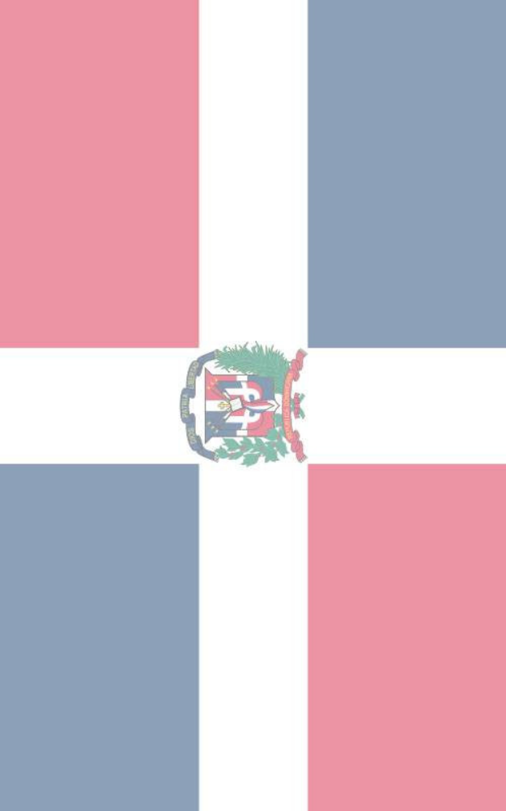
(18-19) Travel
(20-21) Packing
(22) W&W Needs List
(23) Food
(24-25) Checklist
(26-27) Things to Consider
(28) Completed Project: Lecheria
(29-31) Spanish Phrases
(32) Map of the Dominican Republic

The Country

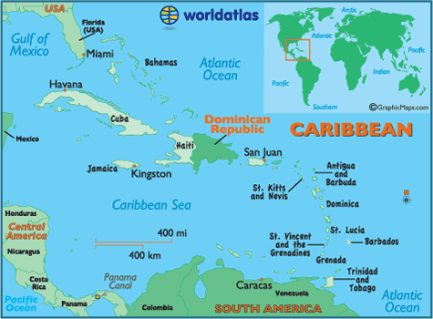
Dominican Republic is located in the middle of the Caribbean Sea, on the eastern two-thirds of the island of Hispaniola. The capital and largest city is Santo Domingo, with a population of 3 million.

The landscape varies throughout the country, and includes mountainous terrain, river valleys, and beautiful beaches. It has a moderate subtropical climate, ample rainfall, and fertile soils. At times, hurricanes and severe storms can cause extensive damage. The country is administratively divided into 30 provinces and one district. The majority of the population is of mixed African and European descent. Spanish is the official language, and Roman Catholicism the official religion. Population growth is a continuing problem in Dominican Republic, and emigration to the United States, particularly to New York City, has been high.

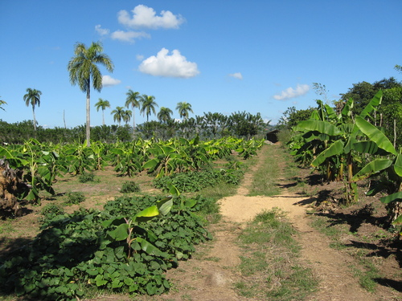
Dominican Republic is currently home to about 10-11 million people. It is the second largest nation in the Caribbean behind Cuba. The average income is around $200-300 U.S. per month, and tourism is the largest source of revenue for the Dominican people. Spanish is the official language, but many people speak English, German, French, Italian, etc. in tourist areas.

The country is largely agricultural. The major crops are coffee, cocoa, bananas, tobacco, sugar, and rice. There are deposits of rock salt, bauxite, copper, platinum, zinc, gold, silver, and nickel; mining has gained importance in recent years. The growth of the nation’s free-market zones has encouraged the growth of various light industries, particularly the manufacture of clothing. Since the late 1960s, tourism has become more and more important to the economy, and several international resort areas have been built. The United States and Great Britain are the main trading partners.

The DR is governed under the 1966 constitution. The president, senate, and chamber of deputies are all directly elected for four-year terms. The major parties are the conservative Dominican Liberation Party, organized by Juan Bosch, and social-democratic Dominican Revolutionary party, organized by Joaquín Balaguer.

History
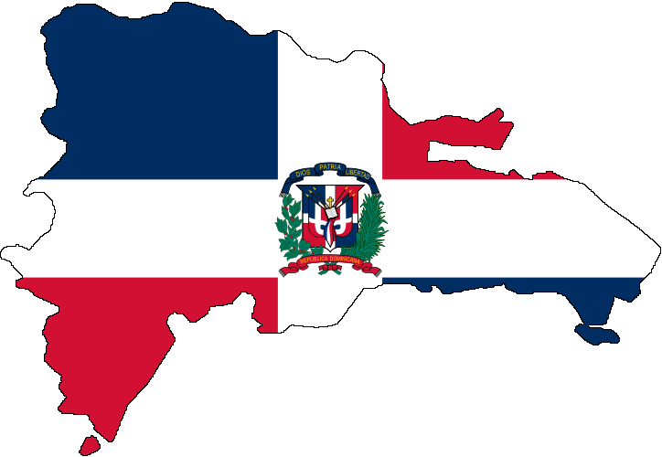
The Dominican Republic has an incredibly rich history. The walls and the cobblestoned streets of its Colonial City bear witness to its past as the first city founded in the Americas.
It was more than 500 years ago that the Dominican Republic began to write its history. The peaceful Taino Indians, who spent their days hunting, fishing and farming, first inhabited the island. Then on December 5, 1492, Admiral Christopher Columbus arrived on the island. He named it Hispaniola, setting into motion the meeting of two cultures that would later make Santo Domingo the first city in the Americas.
For years, Hispaniola went through several changes of power.
Toward the end of the 17th century, the French colonized the western part of the island. In 1795, Spain relinquished power of the eastern part of the island to France, leaving the entire island under French power. The colony temporarily returned to Spanish hands, until December 1821 when a group of men led by José Núñez de Cáceres declared temporary Independence.
That rule didn't last long either.
In 1822 the Haitians took over the eastern part of the island by taking advantage of its military and economic weaknesses. This lasted for 22 years. Then on February 27, 1844, Juan Pablo Duarte began the fight for independence. The new Dominican Republic was born.
Despite the cry for independence, on March 18, 1861 the republic was once again annexed by Spain until after the Restoration War. The resulting political unrest culminated in economic chaos. The Dominican government then received loans with the United States and Europe and gave control of its customs to the US in 1907. Nine years later, the first North American invasion of the country took place.
Various unstable governments followed until the dictatorship of Rafael Leonidas Trujillo was established in 1930. He remained in power for 30 years until he was executed in 1961. This allowed a provisional government to organize the first free elections in 1962. In this election, prominent writer Juan Bosh was elected to the presidency. He was overthrown seven months later, resulting in a civil war led by Francisco Alberto Caamaño. This would lead to the second North American invasion in 1965.
In 1966, Joaquín Balaguer was elected, and led the country through a 12-year period of political repression. In 1978, the country returned to the polls. Balaguer lost overwhelmingly to Antonio Guzmán of the Dominican Revolutionary Party (the PRD). The country was on its way to becoming a democracy. In 1982, the PRD won again under the leadership of Salvador Jorge Blanco. However, in 1986, Balaguer became president again after winning a majority vote. He remained in office until 1996.
After Balaguer's reign was over, Doctor Leonel Fernández of the Party for Dominican Liberation (PLD) became president in 1996. In 2000, the PRD candidate Hipólito Mejía became president, followed by the PLD candidate Leonel Fernández in 2004. He was reelected again in 2008. ¹
In 2012, PLD candidate Danilo Medina was elected to presidency. During his presidency, he is working to create jobs and invest in education.
¹http://www.godominicanrepublic.com/rd/index.php?option=com_content&view=article&id=3&Itemid=9&lang=en

Church of the Nazarene in the Dominican Republic
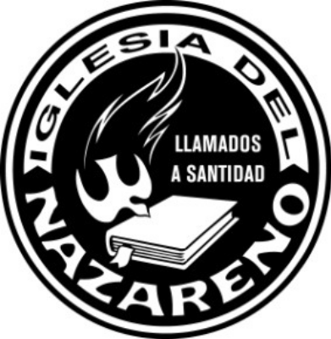
The Dominican Republic is located on the island of Hispaniola. The DR shares this Caribbean island with the Republic of Haiti. The Church of the Nazarene did not officially move into the DR until 1975, but for 20 years before this God was preparing the way. La Hora Nazarena, a Spanish radio broadcast, was
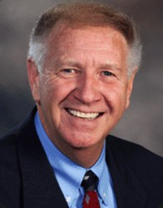
reaching lives long before the country had a church building or even a preacher. Between this global avenue of ministry and the Nazarene Publishing House (Latin Division) making Holiness materials available to other DR evangelicals, the DR was being prepared by God for the introduction of the Church of the Nazarene. In the early 1970s, Rev. William Porter was ministering in Puerto Rico. It was during this time that his attention was drawn to the DR. Rev. Porter traveled to the DR on occasion with the Puerto Rico Symphony. In his travels Porter also met several people who would most likely help him launch the work of the church. In 1972, the World Mission Department passed a motion to officially begin the work in the DR. The leadership, in a strategic move, decided that they would send one of their best into the country, Rev. Louie Bustle. After a year of language preparation in Costa Rica, the Bustles took a five-month furlough. Then in August 1975, the Bustles arrived in the DR.

Before the Bustles arrived, Rev. Porter was busy incorporating the Church of the Nazarene to be recognized officially by the DR government. He also recruited the help and ministry of Rev. Julio Rodriguez, a Free Methodist lawyer, and Mrs. Bobea, who coordinated the effort of La Hora Nazarena in the DR. When the Bustles arrived, they found the field ripe for harvest. For 25 years God had been preparing this country for a great revival. In a short time, with diligent work, the Church of the Nazarene grew in the DR from no churches to 60 churches in 6 years. Membership
Reverend Louie Bustle
continued to rise, and in 1981 they had reached the Phase 3 distinction with over 2000 members. ²

2 http://www.caribbeannazarene.org/wmcaribbeancounrties/trinidadtobago/tabid/90/default.aspx
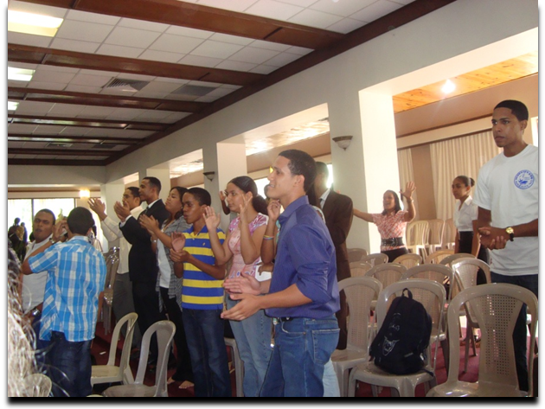
Through the years the DR has continued to grow both numerically and in spiritual maturity. Today the DR supports five Nazarene Districts and 150 churches. Every so often this beautiful land is hit directly with a hurricane. Yet not even the vicious winds can blow down the church that God has built.

In July of 2011, in Santo Domingo, there was a great 36th year anniversary celebration of the Nazarene Church in the Dominican Republic. Dominican Nazarenes from all over the country gathered to celebrate and worship the Lord together.

There is a plan agreed upon by the five districts and national leadership that in the next 5 years, Nazarenes in the Dominican Republic will plant 100 more churches. Churches and leaders in the districts are working hard to accomplish this goal. Many new churches have already been started. This great number of new churches creates the need for many new buildings. In the coming years Work & Witness teams will be essential to help with this endeavor. With God’s blessing and your help, we can make this goal a reality. We need your help!

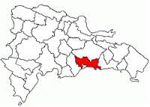
DRC Los Alcarrizos 1st Church of the Nazarene CDC “Camino de Vida”
Location:
Los Alcarrizos, Santo Domingo Oeste
Dominican Republic
Los Alcarrizos is a large city located in the western part of the province of Santo Domingo. Los Alcarrizos 1st Church of the Nazarene is a part of the Dominican Republic Central Nazarene district. It is about a 20-minute drive from the Work & Witness house in Santo Domingo.
Teams working on the Camino de Vida project should fly in and out of Las Américas International Airport (SDQ) in Santo Domingo. Your team will stay at the Work & Witness house in Santo Domingo and travel to the work site daily from there.
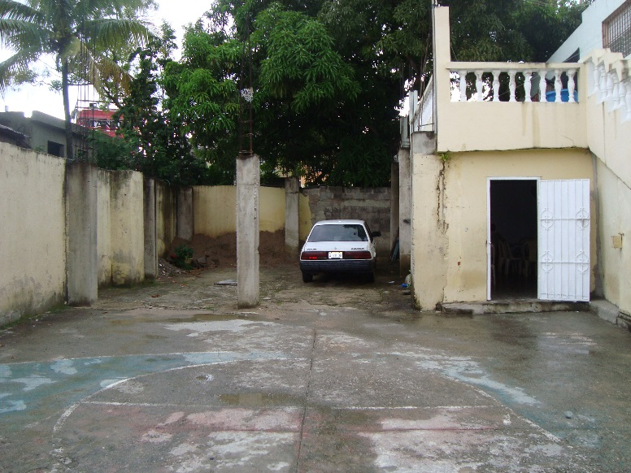
Project Description:

This project includes the child development center “Camino de Vida” that is located at Los Alcarrizos 1st Church of the Nazarene. The director of this project is Neris Matos, the pastor’s wife at Los Alcarrizos 1st.

Neris began the project in 2010 because of the need she saw in the community. When parents work, children are often left alone to fend for themselves during the day. Children struggle in school because parents are unable to help them with homework. Many children live with grandparents instead of parents.
Area next to church/center to continue building

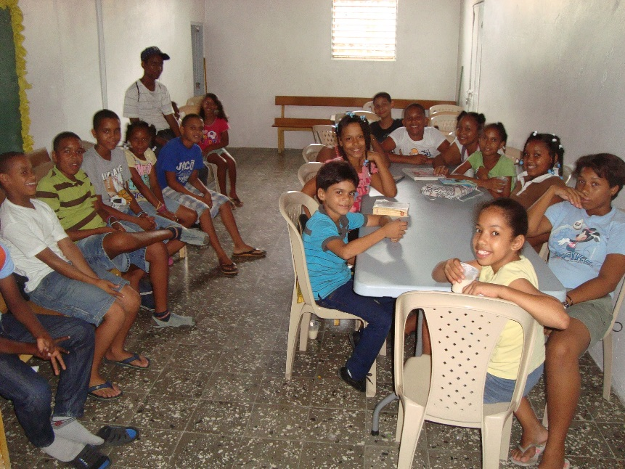
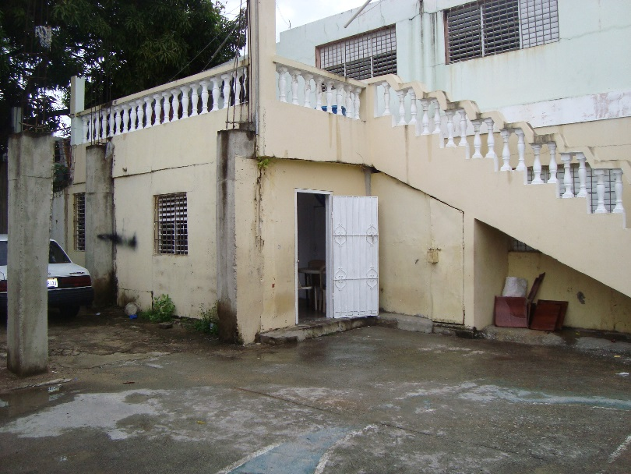
Now, about 100 students attend the center. They serve children as young as 5 years old and teenagers as well. Twenty-nine of these are sponsored through Nazarene Compassionate Ministries. Morning and afternoon classes are held Mondays, Tuesdays, and Wednesdays, and they have recently included a class on Saturdays. “Camino de Vida” is designed to support children in four areas: spiritually, intellectually, social/emotionally, and physically. Children receive Bible training that helps them realize who God is, what He has done for them, and how they can receive Christ as their Savior. “Camino de Vida” provides a study hall where children can receive help with homework or extra help in a certain subject. Many children are taught how to read here. The pastor of the church is a psychologist and some of the teachers also have backgrounds in psychology. They work with children who are having problems, such as familial or social. If a family has a problem, they work with the entire family. Each day, the children enjoy a time of recreation outside. They play games such as basketball or dodgeball. Right now Neris makes snacks for the children in her own home, but she would like a kitchen for the center to be able to provide nourishing meals for the kids.
Children from Camino de Vida

Many more children in the community want to attend the center, but it is not possible right now because there is no space. More rooms need to be built in order to give the center sufficient space to be able to receive all children in need and better minister to them. There is space next to the current center to build. Director Neris and other leaders have the vision to have a kitchen, dining hall, library, office, lounge, and computer center. This would be possible by building the pastor’s home next to the current center and renovating the pastor’s current home (located above the project) to become the new children’s center. This would also allow the church to extend their sanctuary to create more room for their growing congregation.

Work & Witness would love to help “Camino de Vida” build more space in order to serve and minister to more children and youth in Los Alcarrizos. Through Work & Witness, you can be a part of the great transforming work God is doing at this site. God can use you to help change these children’s lives and the community of Los Alcarrizos for His glory!

Leader Roles
We will function more smoothly if the following responsibilities are designated before your arrival.

TEAM LEADER

1. Maintain contact with local W&W Coordinator contact. Email contact information for missionary Beverly Brown is beverly.brown@okstate.edu.

2. In collaboration with the Work &Witness Coordinator, decide on trip dates and specific projects.

3. After trip dates and projects are in place, the Work & Witness coordinator will send you an online team registration link.

4. Inform team members of all details and regularly meet with them to build team relationships.

5. Make travel arrangements and send travel itinerary and list of team members’ names to the field at least 5 weeks before departure. Please note the number of males/females in your group, as well as any married couples. Be responsible for tickets and luggage in airports.

6. Appoint people for the jobs listed below.

7. Be in charge of collecting funds from team members. You are responsible for the provision of cost per day per person.

8. You are responsible for purchasing insurance for your team. You can purchase team insurance by going to the following link. After clicking the link, scroll toward the bottom of the page to the heading: “International Forms”. Click on the appropriate link depending if you want to pay with credit card or by check.

http://workandwitness.nazarene.org/indexa5c5.html

If you have any questions about insurance, please contact Hope Owens at howens@nazarene.org.

9. As the team leader please make sure that all project money (the money that will be used to purchase building materials) is sent into the W&W office in Kansas City at least three months prior to your departure. The link below will take you to the Work & Witness website’s “Resources” tab. Under the ‘Work & Witness Timeline’ heading, there is a link titled “Send Project Funds”. This link will open a Project Fund document. Please use this form when sending funds to the General Treasurer for project/material funds for your Work & Witness trip. When sending your funds, please be sure to specify the name of the project you will be working on. Also, please let Beverly know via email when you send in your funds.

LINK: http://workandwitness.nazarene.org/indexa5c5.html
If you have any questions about this process, you can contact Beverly Brown at beverly.brown@okstate.edu or Hope Owens at howens@nazarene.org.
Remember, for USA-based teams, make checks payable to GENERAL TREASURER, Church of the Nazarene and mail to:
CHURCH OF THE NAZARENE
P.O. BOX 843116
KANSAS CITY, MO 64184
10. We recommend that you bring with you in cash the individual cost-per-day funds. You can give these funds to the W&W coordinator when you arrive. Make sure to bring newer bills without writing or tears in them. If you decide to send these funds in to the General Treasurer, they need to be sent at least 3 months ahead of time.
11. Bring 2 copies of everyone’s passport. The team leader will keep one copy and we will keep the other one.
12. Remind team members to be flexible with the work and understand that work projects are done differently here in the Dominican Republic. Remember that we come to support the work, not take over the work.
13. Remind team members that the team does not come only to build a structure, but to build the church, and the people are the church. It is important to concentrate not only on building a structure but also taking the time to build relationships with people.

SPIRITUAL LEADER

1. Set spiritual goals for group.

2. Set schedule of people to lead devotions / give testimonies / sing.

3. Call on people to pray for meals.
4. Make sure team is prepared to share testimonies. We would like at least 1 person to participate in each service. Participation includes giving testimonies, speaking, a special song, etc.
5. Ask us for prayer requests from the church where you will be working. Also, send us your prayer requests that we can send to them.

WORK LEADER

1. Know the skills and desires of team members.

2. Act as liaison between W&W Coordinator and work team by assigning daily tasks to team members as outlined by the W&W Coordinator.

3. Encourage team members during work by word and example. Let your attitude be like Christ’s: flexible, amenable, loving. Remind team to have fun while working and be safe!

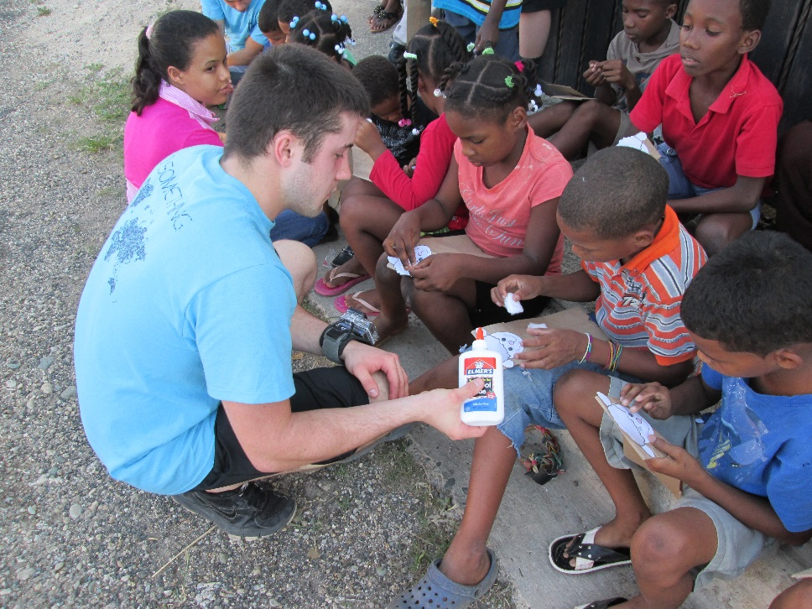
Ministry Opportunities
You will have several opportunities to interact with the people of the DR during your stay here. Along with construction projects, the team is usually involved in 1-3 Vacation Bible School-type activities with the children. Sometimes we hold a VBS somewhere in the community surrounding the project, like in a street or yard, and invite the children in the area to attend. Other times we have VBS activities at a specific church or children’s center. Many times the children’s parents or other adults attend the program as well. Usually children’s activities consist of games, songs, a craft, and a Bible story or testimony from the group. This is a great time to share and interact with the children of the community and show them the love of Christ. If your team is able to bring children’s ministry supplies to use for this type of outreach, that would be very helpful.
While you are here, you will also have the opportunity to attend 1-2 church services either at the church where you are working or another church in area. Your team is welcome to preach, share testimonies, sing, or be involved in some other way during the service. We ask that your team is prepared to be involved in some way during the services. This is a great time to be able to witness and share your personal testimony or something that God lays on your heart to say.
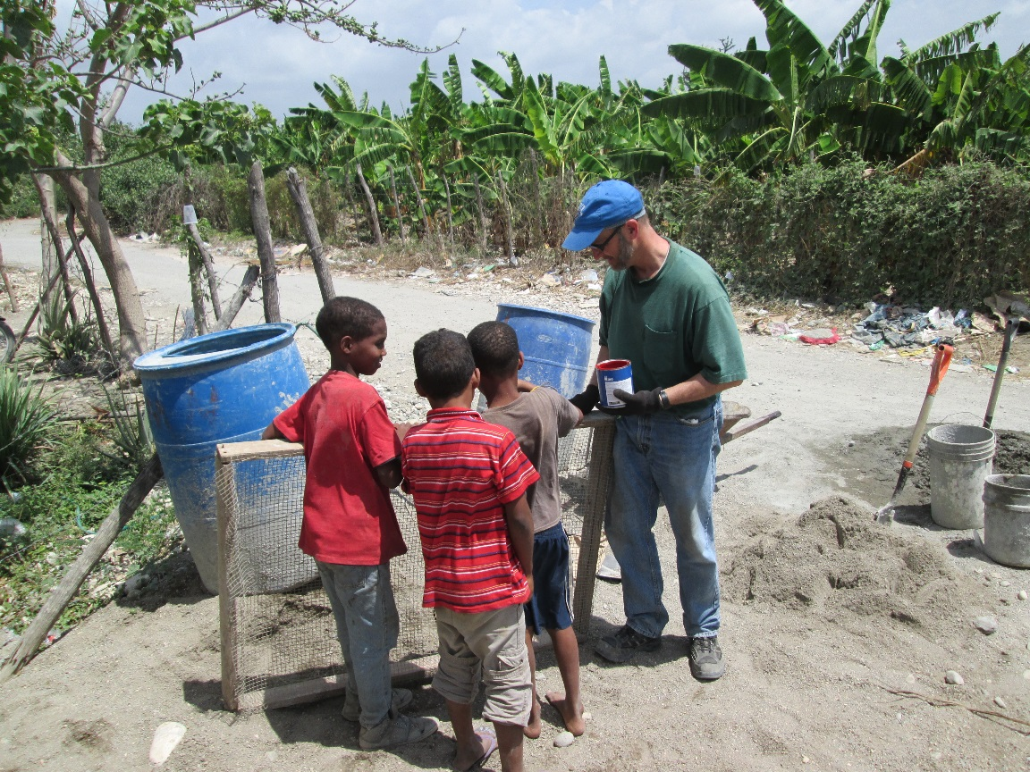
Sometimes teams are involved in the showing of the Jesus Film somewhere in the community. Not all teams do this, and usually it depends on time, equipment available at the location, and the pastor of the church in the community. Usually we go throughout the neighborhood before the movie to greet people and invite them to the showing. Showing this film attracts lots of people in the area and is yet another opportunity to witness and share the Gospel.
You may have an opportunity to be involved in some sort of sports game or practice with youth from the community. Sometimes teams play basketball or baseball games with/against youth from the church and surrounding area. You may also have the chance to help lead a basketball/baseball practice. During this time we always have some sort of devotional or share testimonies.
You will have countless opportunities to share with the people in the midst of the construction work. Almost always, volunteers from the congregation or community work alongside the teams in the construction. You will be able to interact a lot with these volunteers while working. You can be a witness through the way you work as well as getting to know people and sharing Christ’s love with them. Usually there are children helping at the worksite as well. There are always kids around and you may like to take opportunities to take a break from work to play and interact with them.
Individual & Project Costs – Camino de Vida Work and Witness Trip
Individual Cost Per Person
Ground Fees: $50 per person for _____total days traveling=$_________

(This fee will cover food, housing, and transportation expenses while in the DR. We suggest paying these funds directly to missionaries upon arrival. If you choose not to, you will have to cover any money you may spend over the given amount.)

Sightseeing/tourist fee = $50 = $__________
(If your team would like to do extra tourist activities, there will be an additional cost.)

Airfare: $__________ per person = $ __________

W&W Insurance: $ 3.25 per person for _____ days = $ __________

DR Airport Tourist Card per person = $ 10.00 $10

Personal Spending Money: = $ __________

Other: = $ __________

Total: = = $__________

Project Costs – Camino de Vida Work & Witness
Estimated Project Cost:
Requested Project Funds (from your team):

HOUSING

A team would normally fly into Santo Domingo for the most affordable airfare and then spend the first night at the W&W house located west of Santo Domingo. The next day the team typically travels by bus to their project site and stays at any available location. Depending on where the project is located, this could be a hotel, home, or church. The night before the team’s departure is also typically spent at the W&W house outside of Santo Domingo.

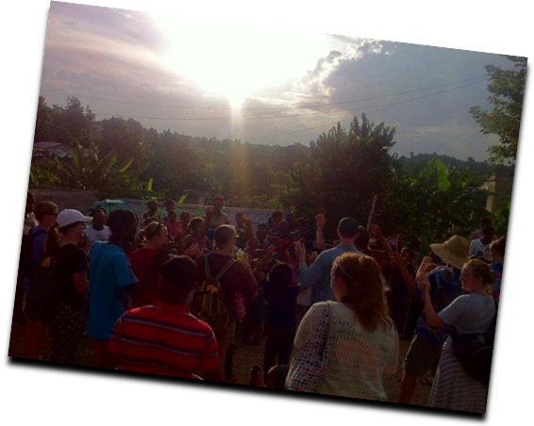
The W&W house is currently under construction to be able to fit teams of 25-35 people. It was built by missionaries, so you will be staying in facilities where previous missionaries and teams have worked. At the house, laundry facilities are available, but at project locations these facilities are not likely. The house has pillows and sheets for your team while you are here so it is not necessary to bring these items. Also, these items will be provided for you if staying at a different location. If you would like to bring your own, however, feel free to do so.

TRAVEL/AIRPORT

U.S. citizens coming to the Dominican Republic need only a valid passport. If team members do not already have a passport, remind them to start the process early as it can take several months. On your flight you will receive an immigration form and a customs form. All team members will need to know the following:

- Purpose of your trip to the DR – “Other”
- Address where you’re staying in the DR :

Calle Mango #39,
Alameda Oeste, Santo Domingo Oeste

The Calle Mango address is that of the National Office. In case of emergencies, you may contact the W&W house phone at 809-372-1108, or Beverly Brown’s cell at 829-762-2341.

AIRPORT

Going through the airport is fairly painless, although it can take some time. The most important thing to remember is that you must stand in line to get a “Tourist Card” This is $10 U.S. per person, and the team leader can purchase cards for every member so that not everyone stands in line. After you have your tourist card, move to the immigrations line with your completed forms. General Rule: Say as little as possible when going through immigrations and customs. Answer questions directly and honestly, but do not bring attention to you or your group by being overly loud or boisterous.

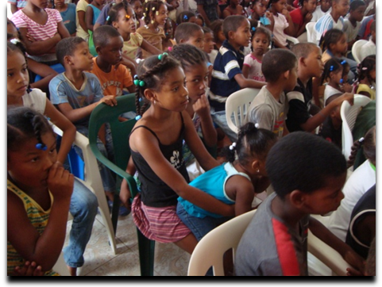
After immigration you will go into the baggage claim. Sometimes heavier bags are pulled off and placed to the side, so make sure to look around. After all bags have been accounted for, gather team and go to the Customs (Aduana) line. The team leader should go first and tell the customs officer how many people are in the group. Again, answer any questions honestly, but do not feel the need to give more details than necessary. The officials are looking for fresh fruits and vegetables as well as people bringing large quantities of items used for business or resale. If asked about any supplies you are bringing, it is okay to say that they are donations for churches. Any food items (such as any snacks you bring) do not need to be claimed.

Once through customs, stay inside the airport and wait for the missionaries to find you.

**DO NOT exchange money at the airport because it does not offer a good exchange rate. We will take your team to exchange money at a different location.

Packing

Baggage: Check with your airline for the cost of checked bags and how much weight is allowed.
- It would be helpful for the Team Leader to have an exact count of checked bags.
- One helpful tip is to use colored duct tape, tags, or some way to identify your bags.

Many teams ask if they can bring donations to the church where they are working or if they need to bring tools. Donations are always appreciated if you are able to bring something. Check with Beverly to see what donation items may be needed at specific projects. There are some specific items needed for the W&W house and projects in general. Please see “Work & Witness Needs” list.

Clothing: Light-weight summer clothing is preferred (washable cottons are coolest).
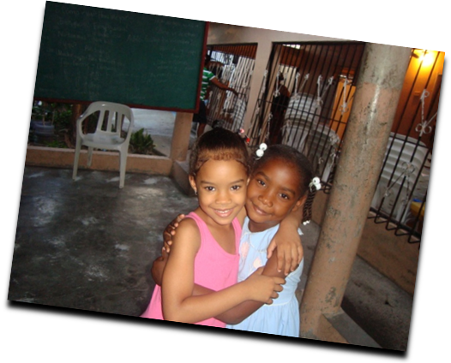
Women: On the work site, it is appropriate for women to wear any of the following: Bermuda length shorts or capris, sleeveless shirts, or short sleeve tops. Please do not bring or wear short shorts, tank tops, or tube tops. It’s hot, so lightweight cotton is best.

For church, please wear skirts or dresses. Pants or sleeveless shirts are not appropriate. Sandals are fine, and you don’t need to bring or wear hose.

It is a good idea to leave nice, expensive jewelry at home. If your wedding ring has large diamond(s), leave it at home. Jewelry can bring unwanted attention to a group (and your group will already stand out as it is). Also, extravagant jewelry is not the most sensitive message we can convey to our brothers and sisters living in a different economic reality.

Men: T-shirts or lightweight shirts and shorts or long pants are worn at the job site, touring and while working. A casual shirt with a collar and khakis or a shirt and tie are appropriate for church services.

- Plan to bring enough dressy clothes for 2 church services. If there are special circumstances, we will let your team know in plenty of time for your team to adjust.

Shoes: Should be comfortable. Sandals for the ladies are appropriate for worship services. You may want to leave some of your clothing behind to make room for souvenirs. Used clothing is sometimes welcomed by churches, but please ask the missionary before you come if this would be beneficial.

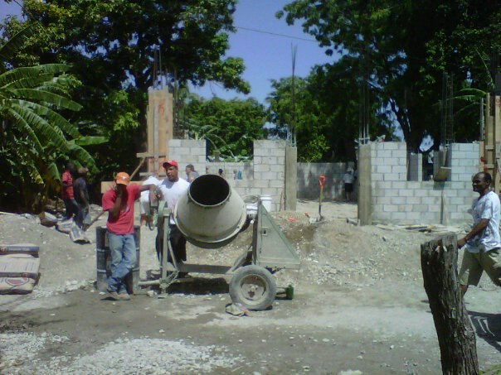
Currency/Misc.
The exchange rate in the DR is approximately 45 pesos to one U.S. dollar. This changes daily. It is better for groups to travel with US money. Do not bring travelers checks.

Please bring newer bills with no writings or tears on them.

Work & Witness Needs
Below is a list of needs for the W&W house in Santo Domingo and projects in general. It is not required, but if your team is able to bring any of the listed items, we would greatly appreciate it!

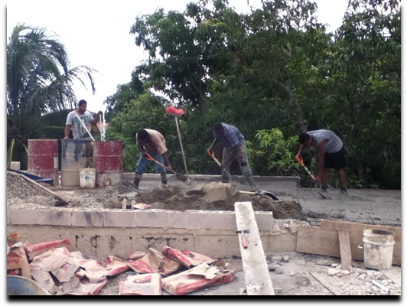
Needs of the W&W House
- cereal bowls
- griddle for cooking
- kitchen knives
- pitchers
- salad spinner
- kitchen towels
- pillows
- pillow protectors
- clothes hangers
- clothes iron
- first aid kits (complete)
Tools Needed for W&W Projects
1. Nail gun
2. Electric hammer to break walls (concrete)
3. Lead level
4. Sets of drills for power drill
5. Power drill
6. Level – (from company Stanley)
7. Hammers
8. Electric saw
9. Saw
10. Hacksaw
11. Trowels
12. Jigsaw
13. Tile Saw
Food

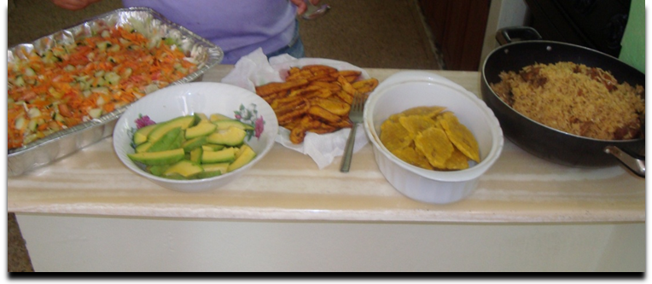
We have ladies who help us with the Work and Witness teams that will cook for us. With the cost-per-day funds we will be buying the groceries here and cooking for you. It is not necessary to bring any food. If you would like to bring personal snacks, that is fine. If your team prefers to cook, that is also fine, but you will be responsible for the provisions and amount of funds spent in that area.

If a team member has any specific food allergy, please let us know in advance. We will do our best to accommodate you in this area. In some cases it may be necessary for you to bring any special product you may need.

Checklists

We have put together a list of items that are needed and not available in the province. There are no stores to stop and buy items that may be needed, but forgotten, so it is important that you come prepared.

Personal Items

Camera
Hat and sunglasses (optional)

Sunscreen and lip balm

Hand sanitizer

Flashlight with extra batteries

Toiletries

Soap, shampoo, deodorant

Toothbrush and toothpaste

Bite / Itch relief stick

Insect Repellent

Ear plugs (really a necessity if you want to sleep)

Fanny pack or equivalent to carry personal items needed at the jobsite (Optional)

Feminine hygiene products

Headache / Pain Relief Medication (or other over-the-counter drugs)
Sleep attire (that can be worn in public)

Flip Flops (or some kind of footwear for showering)

Water bottle

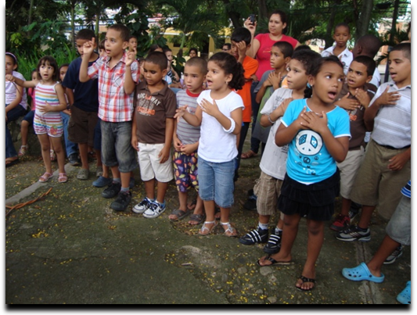
Don’t Forget
- Passport
- Bible
- Notebook
- Pen
- Spending money
- Swimsuit
- Snacks: candy, gum, etc.
- Bring small quantities of medicines you may need (for headache, diarrhea, etc.)

Things to Consider
Camera: Every visitor wants to take pictures. Please do not take pictures at the airport or of political events or military activities. Do be discreet with your camera. It is polite to ask permission before you take pictures of people. Do bring sufficient film as it is expensive in the Dominican Republic. If using a digital camera make sure you have plenty of batteries.

Living Conditions: You may find some parts of the DR that suffer severe problems in housing, health, sanitation and other basic community services. Even if you feel shocked at what you observe, please make an effort to mute your reactions. The people may misinterpret your gestures and feel that you are patronizing them. Remember, in general, the people are a proud people.

You should also be encouraged as you are a part of the overall solution that the Church of the Nazarene is trying to effect. We approach these serious and complex issues from a holistic approach. Sometimes it is necessary to use a band-aid fix, but we are working to have long-term, sustainable solutions for the societal and heart issues that are found in the DR and around the world.

Friendships: Be ready to give the first smile. Dominican people are quick to respond to friendliness and genuine respect. To avoid possible problems for you, we ask that you not exchange addresses or give invitations to visit in the U.S.
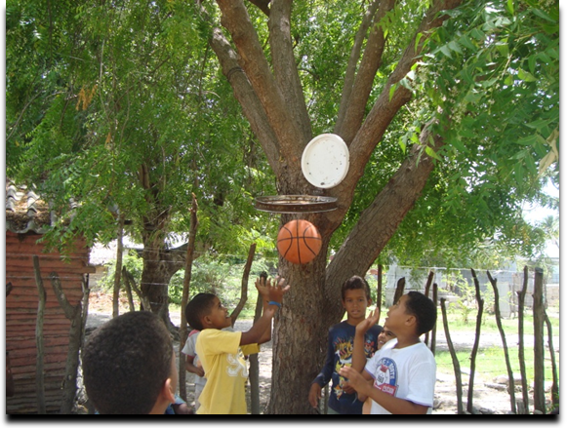
Shopping: Souvenirs include baskets, wood products, embroidered items, pure vanilla and almond extracts, coffee, dolls, metal crafts and paintings. Souvenirs should be small enough to transport easily.

Dominicans can be very enterprising in this economically depressed area. They tend to see all Americans as rich. You are, therefore, a means of making a living. Many helpful actions become
a “service” car washes, opening the door, carrying for you whatever you are carrying, walking with you (even when you prefer to be alone), helping you to bargain in the market...all for a fee! This constant attention can become an enjoyable learning experience. However, do not feel obligated to hire a service. Even with the language barrier, you can say “No” firmly with a smile.
At a market you may try to bargain. We usually offer one-third the price asked to begin. Do not engage in bargaining unless you want to purchase an item. We will also take you to shops with fixed prices, and in many cases, better quality products than on the street. Since we usually shop as a group, it will not always be possible to find everything you want. Shopping can be like “garage sale” shopping. You never know when a bargain will show up and you may not be able to find it again. Your coordinators can assist you in your purchases.
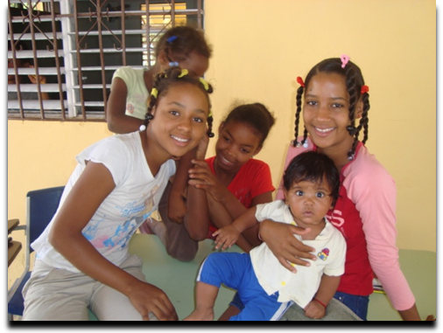
Giving: Always, always, always work through the missionaries if you feel led to give money, clothes, or anything. Money coming from missions groups can actually jeopardize the local church’s work if not handled well. We absolutely encourage giving, but it needs to be done in a way that ultimately benefits the local church.

Dating: Some wonderful friendships can start on a W&W trip. However, “dating” as is common in the U.S. is very different than in the DR, especially among Christians. For the sake of the work, we ask that displays of affection be reserved for married couples only.

Money: Normally team members exchange between $50-100. Please bring small U.S. bills (1’s, 5’s 10’s). The exchange rate varies daily in the Dominican Republic. Do not bring travelers checks.

Witnessing: Please recognize that in many ways, “the work is the witness.” The manner in which you labor, your acceptance of strange food, frustrating customs, unpleasant conditions, and hard work will bear witness to those around of your life with Christ (see John 17).

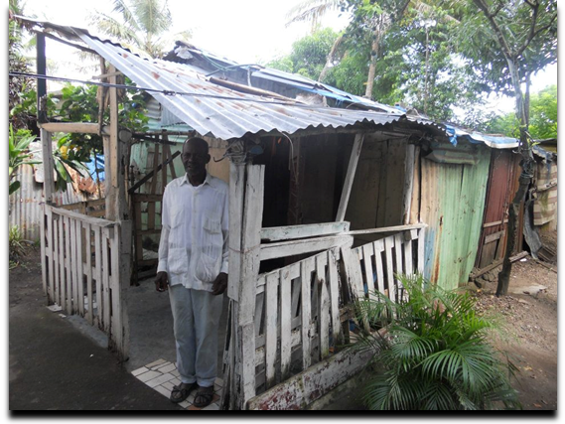
You are important. God can use you to transform lives!
Lecheria Church of the Nazarene before
Parsonage at Lecheria before
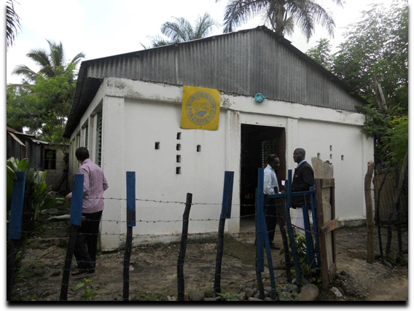

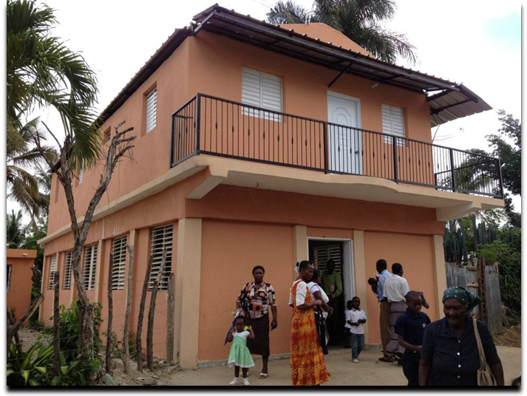

Lecheria Church of the Nazarene and parsonage after. The parsonage is the 2nd floor.

Spanish Phrases

Greetings:
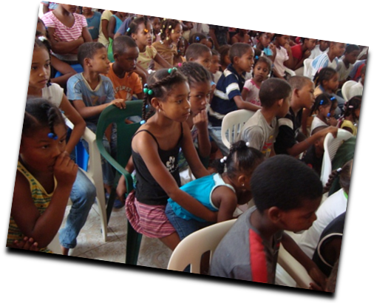
Hello / Hola
Goodbye / Adios
Good morning/good day / Buenos dias
Good afternoon / Buenas tardes
Good evening/night / Buenas noches
How are you? / Como esta usted?
Very well thank you / Muy bien, gracias
See you soon / Hasta luego
That’s all right / Esta bien
Don’t worry / No se preocupe

Useful Statements:
I (don’t) like it / (No) me gusta
I’m not sure / No estoy seguro
I don’t know / No se
I think so / Creo que si
I’m hungry (thirsty) / Tengo hambre (sed)
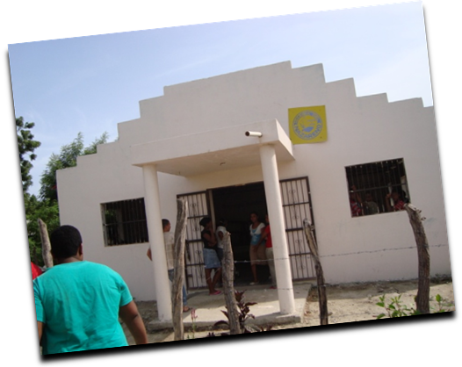
I’m tired / Estoy cansado

I’m ready / Estoy listo
Just one minute / Un minuto por favor
One moment please / Un momento por favor
Come in / Adelante
It’s cheap (expensive) / Es barato (caro)
It’s cold (hot) / Hace frio (calor)
It’s too much / Es demasiado
That’s all / Es todo
Thank you for your help / Gracias por tu ayuda
Taxi please / Taxi por favor

Language Problems:
Do you speak English? / Habla Ingles?
Do you understand me? / Me entiende?
I don’t speak Spanish / No hablo Español
Please speak slowly / Hable despacio por favor
I don’t understand / No entiendo

Opposites:
Before (After) / Antes (Despues)
Early (Late) / Temprano (Tarde)
First (Last) / Primero (Ultimo)
Here (There) / Aqui (Alli)
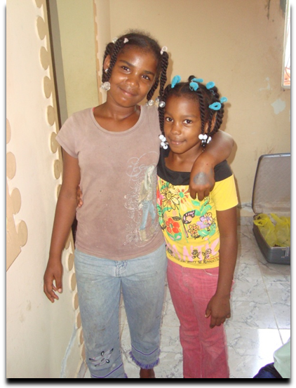
Now (Then) / Ahora (Entonces)
Small (Large) / Pequeño (Grande)
Empty (Full) / Vacio (Lleno)
Few (Many) / Pocos (Muchos)
More (Less) / Mas (Menos)
Beautifu l(Ugly) / Bonito (Feo)
Better (Worse) / Mejor (Peor)
Clean (Dirty) / Limpio (Sucio)
Cold (Hot) / Frio (Caliente)
Open (Closed) / Abierto (Cerrado)
Common Phrases:
Yes / Si
No / No
Please / Por favor
Thank you / Gracias
You’re welcome / De nada
No thank you / No gracias
Sorry / Perdone
What is your name? / Como se llama?
My name is ___ / Me llamo ___

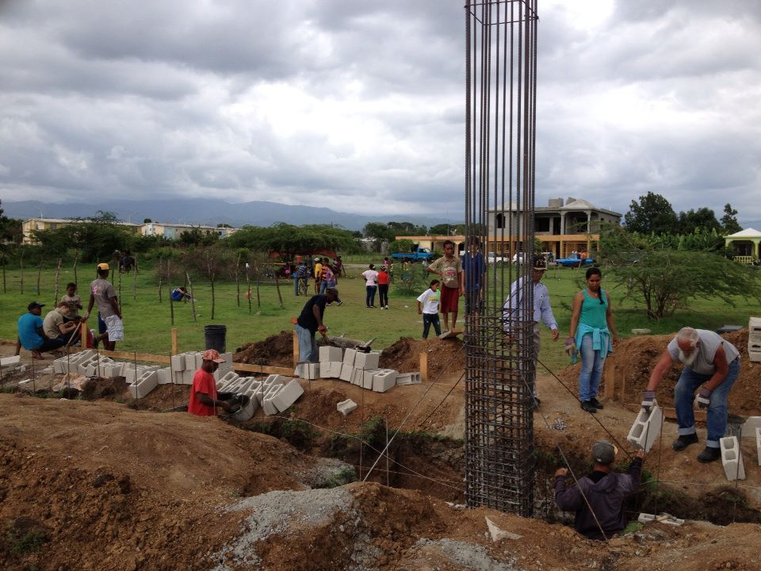
Questions:
Where is(are)? / Donde esta(estan)?
When? / Cuando?
Who? / Quien?
Why? / Por que?
What? / Que?
How much is (are)? Cuanto cuesta)?
How far? / Que distancia hay?
I want (would like..). / Quiero...
What is the matter? / Que pasa?
Can you help me? / Puede usted ayudarme?
Can you show me? / Puede usted enseñarme?
Can you tell me? / Puede usted decirme?

In A Restaurant:
I’ve reserved a table / Reserve una mesa
Waiter (Waitress) / Camarero(Camarera)
May I have the menu? / El menu por favor?
I’d like... / Quiero...
A little more / Un poco mas
What will you drink? / Que desea beber?
This is bad / No esta buena
Glass of water / Un vaso de aqua
Ice (cubes) / Hielo
The bill please / La cuenta por favor
Breakfast / El desayuno
Lunch / El almuerzo
Dinner / La comida(la cena)





